**FIN521: Advanced Corporate Finance**

Case 3: Midland Energy

Soyeon Chang, Wanbae Park, Inhyuk Lee, Sangwoo Park

1. For what types of decisions are Mortensen’s estimates of Midland’s cost of capital used?

* Midland’s cost of capital are used in analysis including asset appraisals for both capital budgeting and financial accounting, performance assessments, M&A proposals, and stock repurchase decisions.

2.

a. What is Midland’s current Net Debt and market leverage? (you can assume all cash is excess except “restricted cash”)

* Net Debt = Current portion of LT debt + LT debt - Cash and Cash Equivalent = 101,845 - 19,206 = 82,639
* Market leverage = Debt/ ($stock * share outstanding) = 82,639 / 130168.61 = 63.49%

b. Calculate Midland’s current cost of equity, cost of debt, and corporate (firm-level) WACC. Note: To calculate the cost of debt capital you can assume that the firm’s βD=0.05, and that this debt beta stays constant in a reasonable range around the Midland’s target leverage (*i.e.*, *ignore* the yield spreads given in Table 1 in the case and the discussion on the bottom of page 5).

|  |  |
| --- | --- |
| Risk free rate | 4.98% |
| EMRP | 5.00% |
| βd | 0.05 |
| tax | 40.00% |
| Cost of Debt | 5.23% |

|  |  |
| --- | --- |
| βe | 1.25 |
| Cost of Equity | 11.23% |

|  |  |  |
| --- | --- | --- |
| Equity | 130168.61 | 61.17% |
| Debt | 82,639 | 38.83% |
| Total | 212807.6808 |  |
| WACC | 8.09% |  |

c. What would Midland’s corporate cost of equity and WACC be if Midland reaches its “target” leverage of 42.2% (net)debt/value?

|  |  |  |  |
| --- | --- | --- | --- |
| Target Leverage | 42.20% | Unlevered cost of asset | 8.90% |
| spread to treasury | 1.62% | Target cost of equity | 10.58% |
| Target Cost of debt | 6.60% | Target WACC | 7.79% |

3. Should Midland use a single corporate WACC for evaluating investment opportunities in all of its divisions? Why or why not?

* No, as risk exposure, business characteristics and beta of each divisions are different, separate cost of debt and equity should be used.

4.

a. Using the data provided in Exhibit 5, compute a separate cost of capital for the E&P and R&M divisions. 1 Assume the E&P division has a 46% D/V and the R&M division has a 31% D/V. Also assume (following Table 12.3 in the textbook) that at these debt levels, the E&P division’s βD,E&P=0.05 and the R&M division’s βD,R&M=0.1.

|  |  |  |  |
| --- | --- | --- | --- |
| βd (E&P) | 0.05 | βe (E&P) | 1.21 |
| Cost of Debt | 5.23% | Cost of Equity | 11.03% |
| D/V | 46% | WACC | 7.40% |

,where equity beta of E&P division is equity beta of Wide Plain Petroleum, with similar capital structure.

|  |  |  |  |
| --- | --- | --- | --- |
| βd(R&M) | 0.1 | βe(R&M) | 1.335 |
| Cost of Debt | 5.48% | Cost of Equity | 11.66% |
| D/V | 31% | WACC | 9.06% |

,where equity beta of R&M is average equity beta of Arkana Petroleum Corp.(1.25) and Dameron Fuel Services(1.42).

b. What are the drivers that causes these WACCs to differ from one another?

* As two divisions of business have different betas as they contains the different risk exposure. As a result, both cost of debt and equity of E&P division are smaller than that of R&M division.
* But most of all, Capital structure is the key driver to decide WACC as leverage provides the tax benefit. Highly leveraged company takes more advantage through debt financing and lower WACC. Therefore, WACC of E&P with high leverage as 46% is way smaller than that of R&M even though difference in debt cost of capital and equity cost of capital is less than 1%.

5. a. Collect data on comparables (*i.e.*, at least three companies with businesses related to the Petrochemicals industry) from your favorite source of financial information (e.g., CapitalIQ, Bloomberg, Yahoo Finance), and use this data to compute a cost of capital for the Petrochemical division (you would ideally get this data from around the same time in 2007, although that’s not required). Assume the Petrochemicals division has a 40% D/V ratio and βD=0.05.

* We have collected equity betas of companies in petrochemical industry at 2007. Data was collected from Bloomberg.

|  |  |
| --- | --- |
| Beta in 2007 | |
| BASF | 0.88 |
| Dow Chemical | 0.95 |
| Ineos | 0.56 |
| Dupont | 1.15 |
| Formosa Plastics | 0.71 |
| Mitsubishi Chemical | 0.91 |
| Average Beta | **0.86** |

* By using the average beta above, cost of equity of petrochemical division of Midland Energy was calculated, and it was 8.19%. Using debt beta, cost of debt was calculated as 6.33%. Given D/V = 40%, and tax rate = 40%, WACC is calculated as 6.4344%.

b. How would the equity beta and WACC vary for different levels of leverage for this division? Plot i) equity beta on D/V, and ii) WACC on D/V (for each D/V between 0%-100% in 10% increments). *Hint:* You will need to “guesstimate” how βD will change with leverage, but you nevertheless know that βE at D/V=0% = βD at D/V=100% =βA.

* The plot below represents equity beta corresponding to D/V ratio. It can be shown that equity beta increases as debt-to-value ratio increases. It is consistent to Modigliani and Miller theorem.

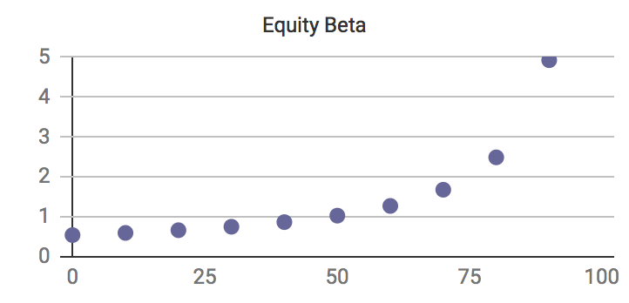

* The plot below shows WACC correspond to D/V ratio. It shows that WACC decreases as debt-to-value ratio increases. It is because increase in debt has a tax shield.

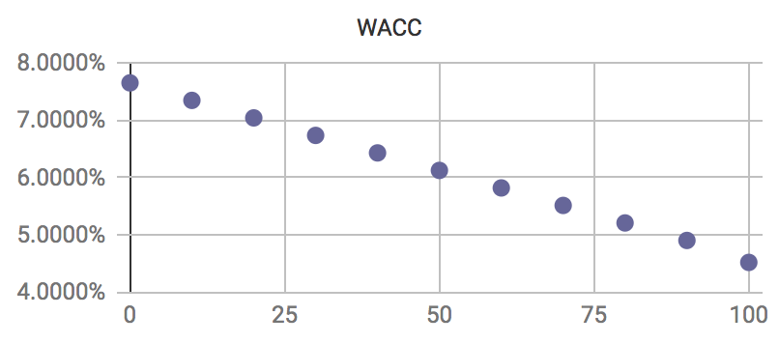

6. Bonus question (somewhat difficult): How could you use only data from the case to estimate a WACC for the Petrochemical division? What are potential shortfalls of this method? *Hint:* The beta of a portfolio is a value-weighted average of the betas of the individual assets; to get estimates of the “stand-alone” divisional enterprise values of the E&P and R&M divisions you may, for example, use revenue multiples with their comps.

|  |  |  |  |  |
| --- | --- | --- | --- | --- |
| ***Enterprise Value*** |  |  |  |  |
| Market Value of Equity | 130,169 |  |  |  |
| Net Debt | 82,639 |  |  |  |
| Enterprise Value | 212,808 |  |  |  |
|  |  |  |  |  |
| ***Using Comps, estimate EV of each division*** | |  |  |  |
|  | ***E&P*** | ***R&M*** | ***Petrochemicals*** | ***Whole*** |
| Operating Revenue | 22,357 | 202,971 | 23,189 |  |
| EV / Revenue | 3.70 | 0.51 |  |  |
| Estimated Enterprise Value | 82,751 | 103,048 | 27,009 |  |
| Weight | 38.89% | 48.42% | 12.69% |  |
| WACC | 7.40% | 9.06% | **6.48%** | 8.09% |

* We used the following steps to get petrochemicals’ WACC.
* step1 : Calculate Enterprise Value of comparable companies
* step2 : Calculate EV/Sales(multiple)
* step3 : Petrochemicals EV = Whole EV - (E&P EV + R&M EV)
* step4 : Calculate each division weight
* step5 : Calculate Petrochemical’s WACC